**ARC 5743**

**Hose by Foot Auto Work Order Generation Dashboard**

This project is a modification of the 5381 Auto Work Order Generation Dashboard. It was created for Mercedes Textiles for generation multi part work orders for different length hoses.

Requirements/Assumptions:

* All parts meant to be used with this dashboard have their length stored in the Inventory > File > Inventory Parts > Open > Options length field.
* All parts to be used with this dashboard have their router stored in Inventory > File > Inventory Parts > Open User Field 1
* The router for these parts is to make one foot of the part.

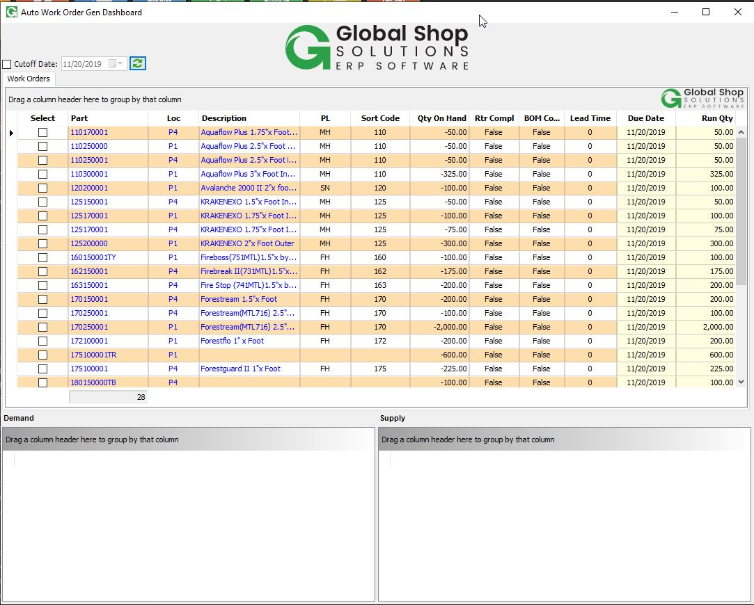

When launching the dashboard, it will load all requirements for the valid parts. These requirements will come from the individual parts with lengths, but will be converted and consolidated into the router (single foot) part on this menu.

Click refresh to load the data. A cutoff date may also be selected to only view requirements up to a certain date.



Click the Part or Loc columns to load the supply and demand for that part in the supply and demand grids at the bottom of the screen.

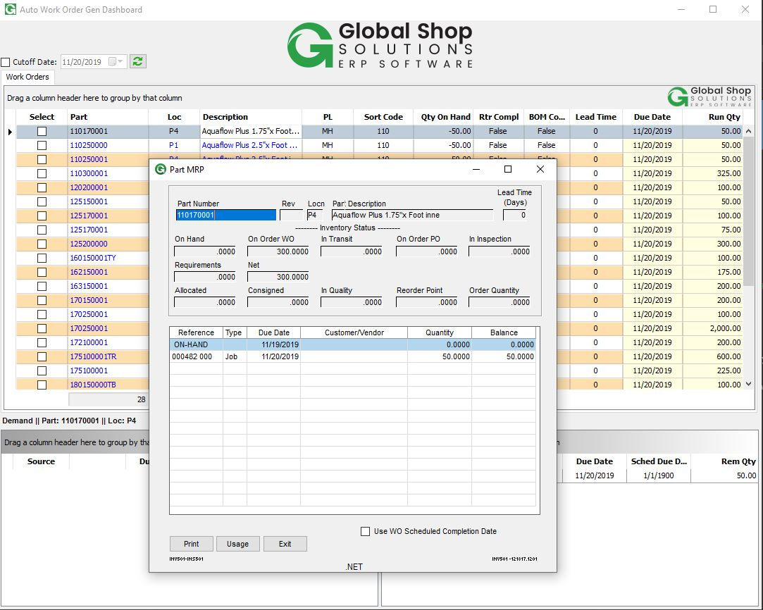

Click the Description column to bring up the MRP screen for that part.



The due date and run quantity columns can be modified at this point.



To create the work orders, select the parts you wish to create them for, right click, and select Create WO (Multi-Part). The work order will be created for that date and quantity, and all parts with that router (single foot part) in their User Field 1 will be added to the work order as multi parts.

In the right click menu you can also refresh, export, select/deselect all, and choose Create WO (Manual) to open up Shop Floor Control > File > Work Orders > New.